Preliminary Analysis – Variety

< What are the factors and results of cultural diversity?>

1. Data Gathering

We gathered several data to compare with Cultural Diversity. We first filtered raw data, because there were a lot of N/As in the raw data. We deleted all the N/As in each data and made each one into csv file for more elaborate analysis. Here are some examples of data we gathered.

Consumer Price , Crime Rate, Economic Freedom, Gender Inequality, Global Peace, GNI/person, Human Development, Life Expectancy, Total Fertility Rate, Urbanization Rate.

1. Descriptive Analysis

Here are some descriptive analyses of our data.

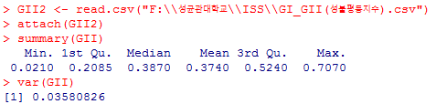[Gender Inequality] 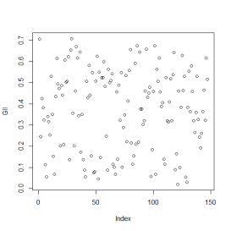

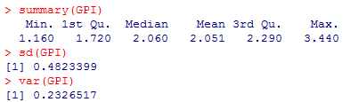 [Global Peace] 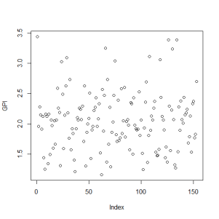

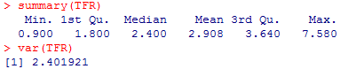 [Life Expectancy] 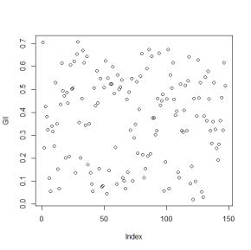

1. Advanced Analysis

We want to know the factors and result of cultural diversity, so we thought that figuring out correlation between cultural diversity and other potential factors was the next step. Therefore, we plotted both cultural diversity and other factors. Moreover, we used “cor.test” to know the correlation between them. Here are some examples of data that had relatively good correlation with cultural diversity.

Gender Inequality, Global Peace, Human Development, Life Expectancy, Total Fertility Rate, Consumer Price(without outlier)

[human development]

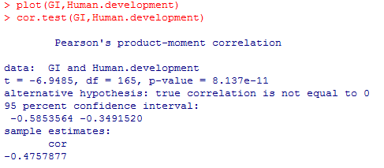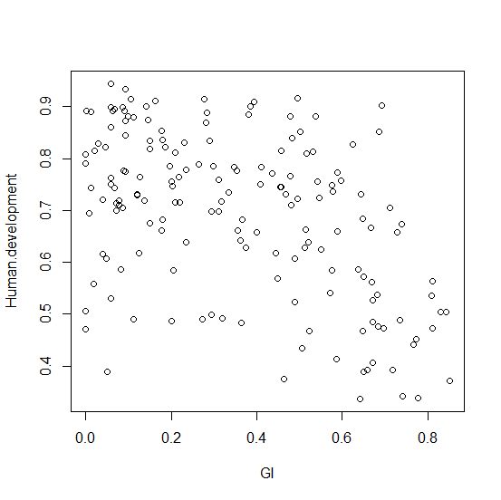

[Life Expectancy]

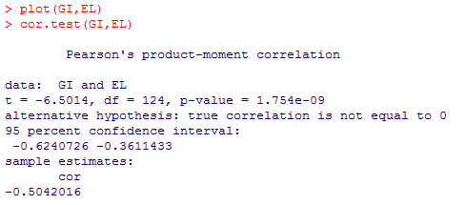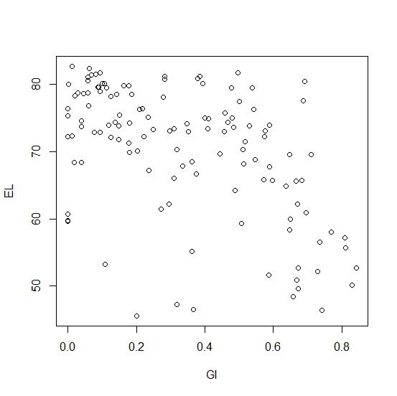

[Total Fertility Rate]

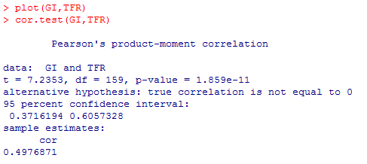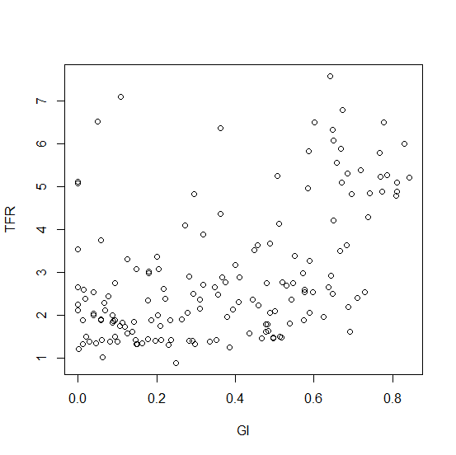

Figuring out correlation between consumer price and cultural diversity, we found out that there was an outlier. Therefore, we deleted this data, getting better p-value and coefficient of correlation.

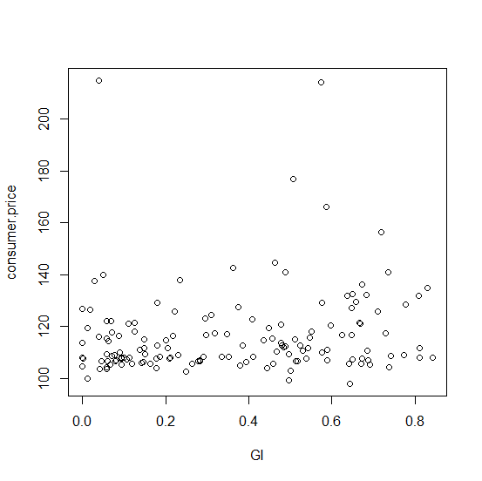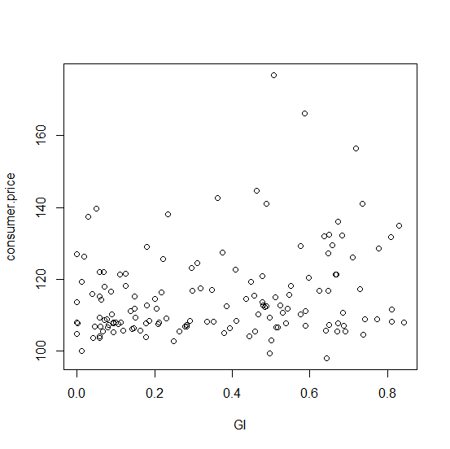

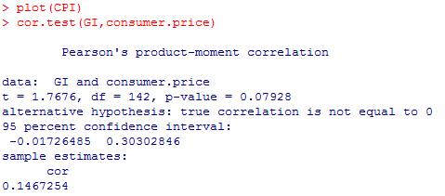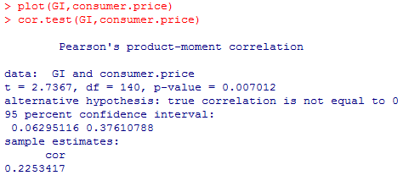

1. Next Steps

We analyzed correlation between some factors and cultural diversity. Based on this result, we will find factors and results of cultural diversity. Here are some steps what we will take.

1. Find more data that seems correlated with cultural diversity
2. Find correlation of all data again and look into coefficient and p-value.
3. Based on basic analysis, find out linear equation of some indexes and cultural diversity through regression.
4. Based on advanced analysis, find out factors and results of cultural diversity.
5. Interpret the result of analysis in some information sources.